Upcoming Events
Family Camp – HOLD FAST May 26-28
Camp Roganunda 3200 River Road Naches, WA
GO Rallies – Kalispell, MT June 23-24 Kennewick, WA June 26-27
Northwest Region Convention July 7-9
812 W. 19th Ave
Kennewick, WA

General Assembly August 7- August 12, 2023
Westmore Church of God
2440 Legacy Pkwy NW
Cleveland, TN

Washington State Pastors:
Kennewick- Jesus Sosa
Pasco- Roberto Contrares
Yakima- Brenda Dilger
Sedro-Woolley- James Hughes Jr

Available for revivals:
Evangelist Chris Jones 208-308-8876

The Church of God
Washington District Convention
at Central Assembly of God
701 S. 3rd Ave.
Yakima, WA 98902

March 31 – April 1, 2023

I Press Toward The Mark

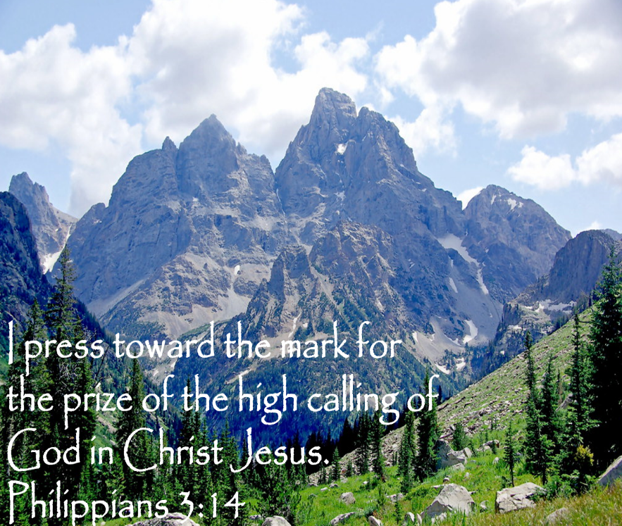

Friday Night
6:30 Preliminary Music
6:45 Open Convention – James Hughes
7:00 Worship Service – Sister Smith
7:15 Yakima Church Boost – Sister Dilger
7:30 Church of Prophecy Marker Association Boost – Brother Rick Dilger Women’s Missionary Band Boost – Sister Dilger
7:45 Message / Alter call – Sister Brenda Dilger Yakima, WA

Saturday Morning
9:30 Preliminary Music
9:45 Scripture and Prayer – Sister Nancy
Genesis 6:1-9

10:15 Worship Service– Sister Connie
10:30 Kennewick Church Boost – Brother Marcos
10:45 VLB Boost – Sister Demarius Sosa
11:00 Message – Brother Jesus Sosa Kennewick, WA
Dismiss for Lunch

Saturday Afternoon
2:00 Preliminary Music

2:15 Scripture and Prayer – Sister Amy Hughes
John 17:13-23

2:30 Worship Service – Sister Amy Hughes
2:45 Message – Bishop Smith, Northwest Region Overseer
3:30 Sedro-Woolley Church Boost – Brother James Hughes
3:45 Family Camp Boost – Sister Amy Hughes Evangelism Boost – Brother Hughes
4:15 Message / Alter Call – Evangelist Chris Jones Sedro-Woolley, WA
NOTES:___________________________________________________

_________________________________________________________

_________________________________________________________

_________________________________________________________

_________________________________________________________

_________________________________________________________

